PRE-OPERATIVE SHOPPING LIST
The following is a list of items that should be purchased prior to surgery in order to prepare for and more easily recover after surgery.

Arnika Forte:  Homeopathic remedy with arnica montana and bromelain active ingredients that is used to help reduce inflammation and minimize bruising.  Where to buy: You can find Arnica in several over-the-counter products, including creams, tablets and gels. We offer the Arnika Forte Kit for purchase at our office for $30. Generic brand of Arnica can be purchased at Target, Walgreens, Walmart, GNC, Vitamin Shoppe. | 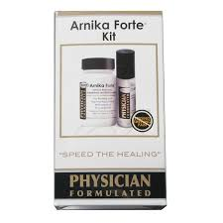
Pineapple:
Pineapple contains the enzyme bromelain and the antioxidant vitamin C. Bromelain speeds healing by reducing inflammation and minimizes the occurrence of bruising. Vitamin C helps build and repair bodily tissue and promotes wound healing. Pineapple consumed specifically to support healing from surgery should be raw and unprocessed, as canning or pasteurizing will damage the important enzymes.
Tylenol or a generic form of this drug:  For pain once prescription strength pain medications are no longer needed.  Where to buy: Walmart, Target, Walgreens, CVS | 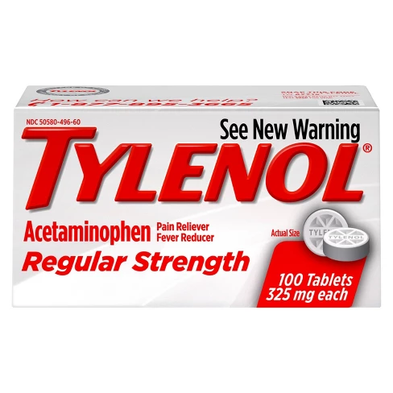
Puppy Pads:
Absorbent disposable pads for drainage of tumescent solution
Where to buy: Target, Walmart, CVS, Walgreens
Brazilian Butt Lift Recovery Pillow:  Alleviates pressure from buttocks to thigh area  Where to buy: Online at Amazon.com | 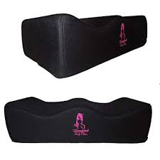
Mattress Protector/Shower Liner:  Barrier helps to prevent moisture damage and staining on mattress and sheets.  Where to buy: Walmart, Target | 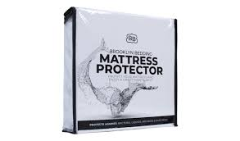
Triple Antibiotic Ointment:  To keep incision area moisturized after surgery  Where to buy: Walmart, Walgreens, CVS, Target | 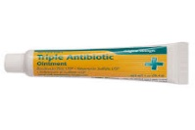
4x4 Gauze Pads:  Where to buy: Walmart, Walgreens, CVS, Target | 